**Steps to Setup Hortonworks Sandbox on Windows**

Contents

Download Hortonworks Sanbox 1

Download and install VM Player 2

Setup Hortonworks Sandbox in VM Player 9

Verify hadoop services using ambari. 14

# Download Hortonworks Sanbox

1. Go to the below link and download Hortonworks sandbox latest version

<https://www.cloudera.com/downloads/hortonworks-sandbox/hdp.html>

1. Select VMWARE as installation type.

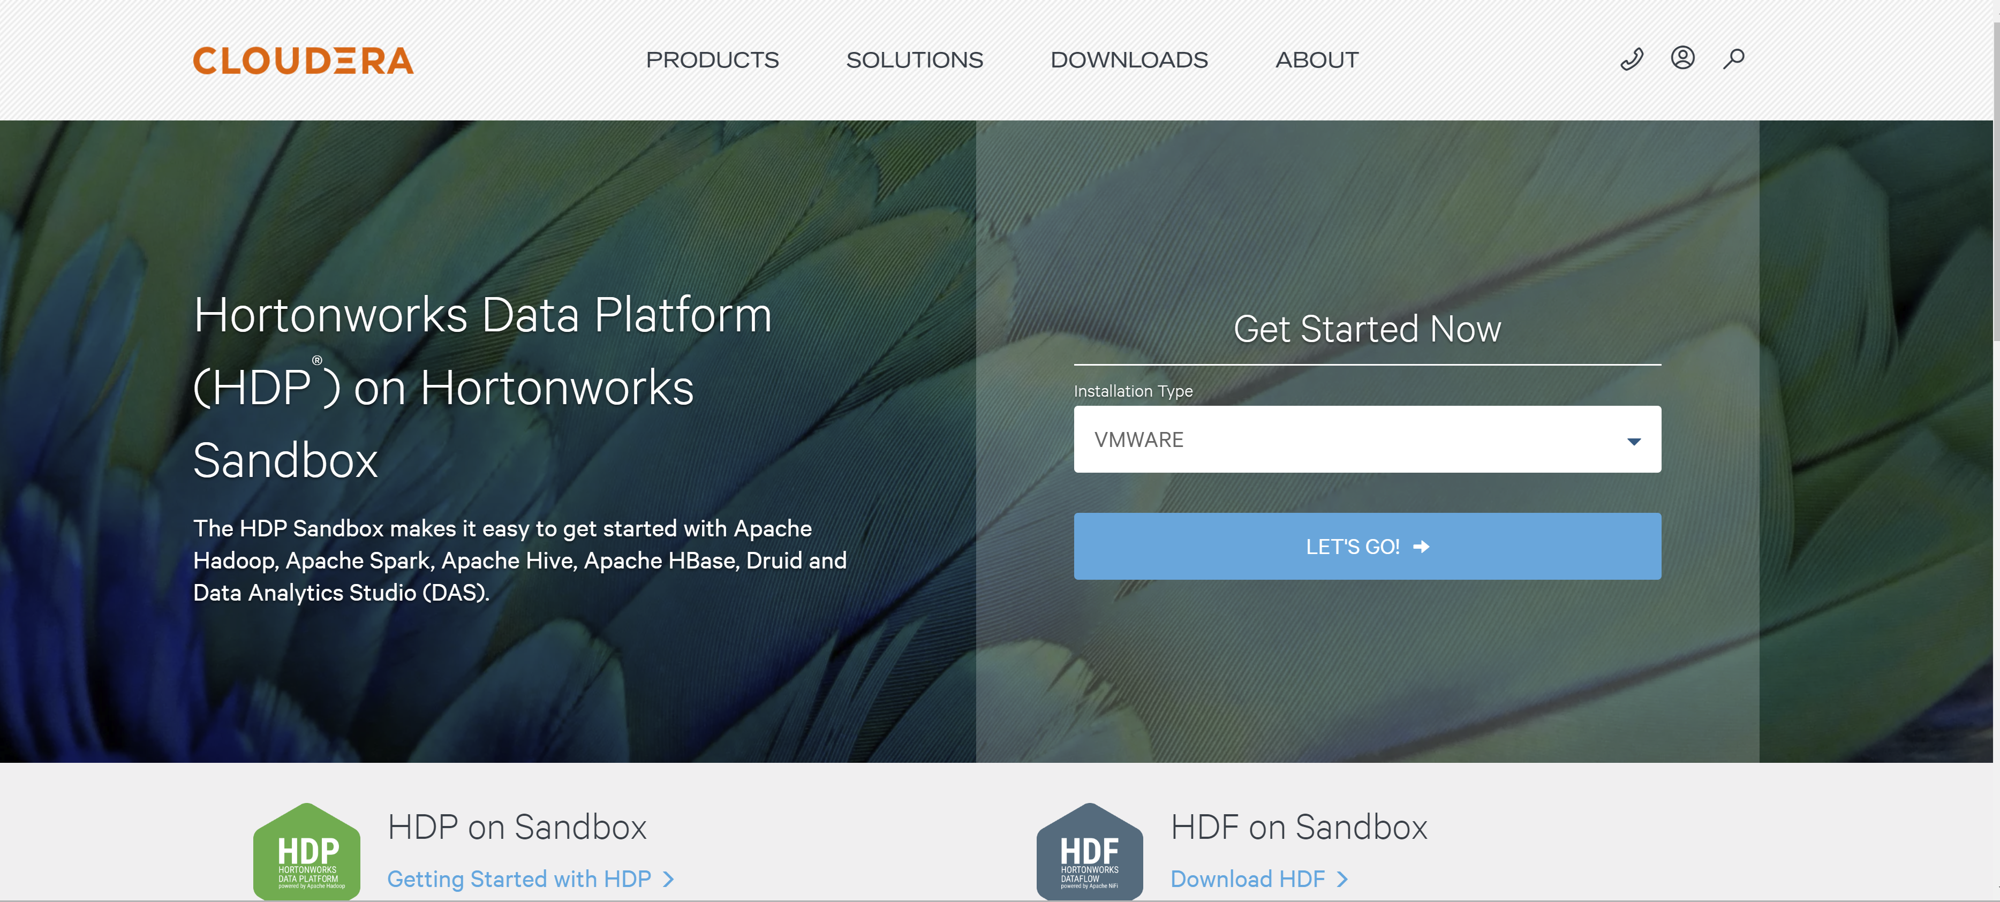

1. Fill in the required details and submit.

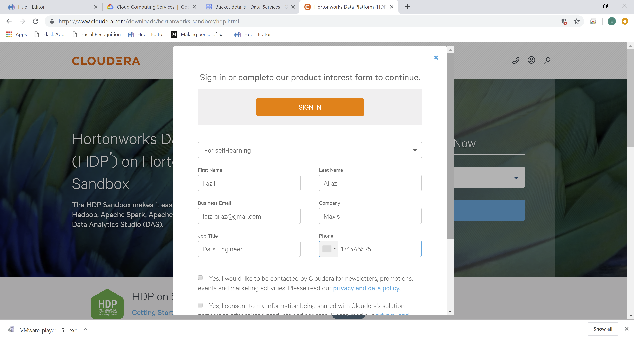

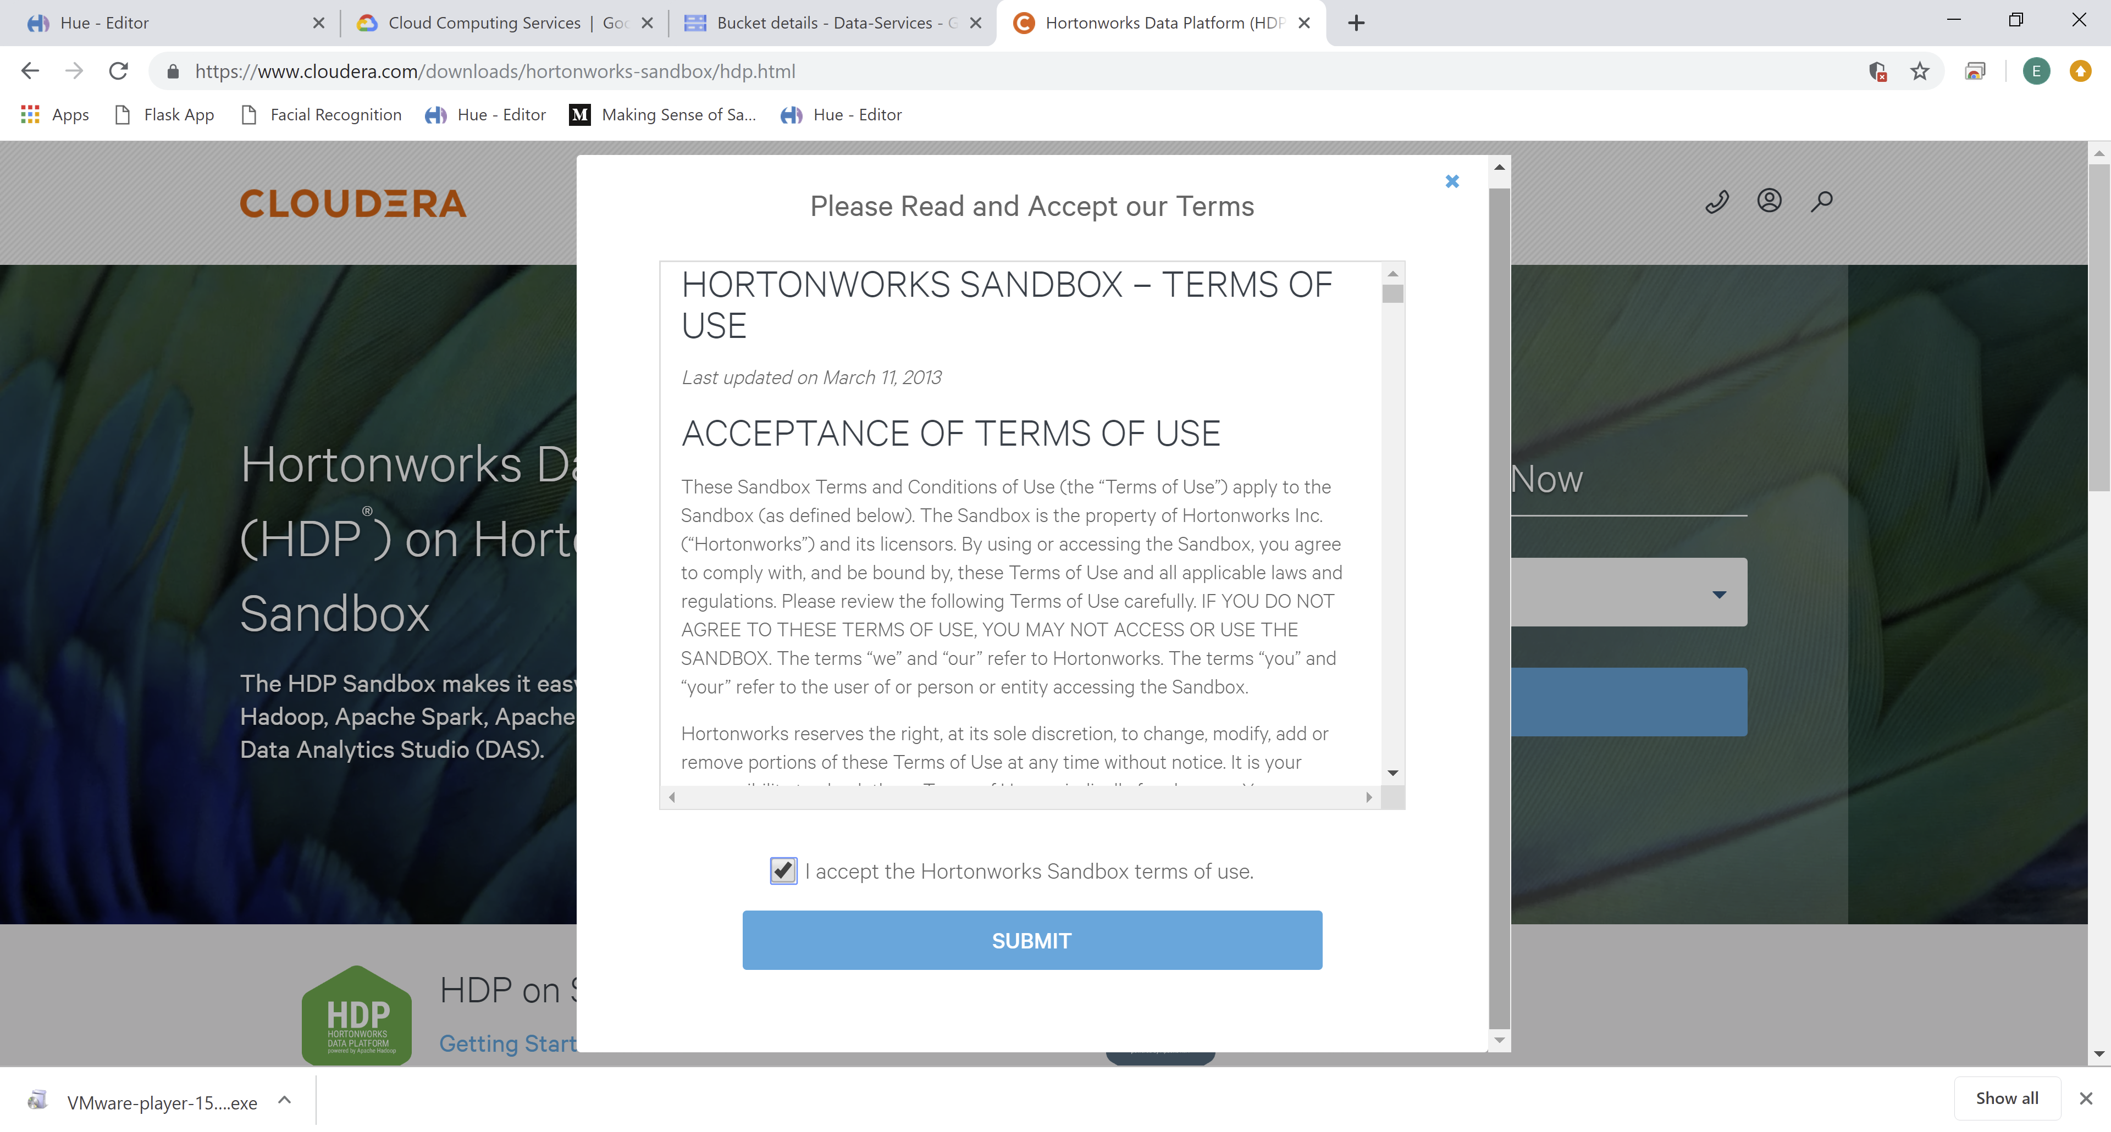

# Download and install VM Player

1. Go to below link to download the VM Player:

<https://www.vmware.com/my/products/workstation-player/workstation-player-evaluation.html>

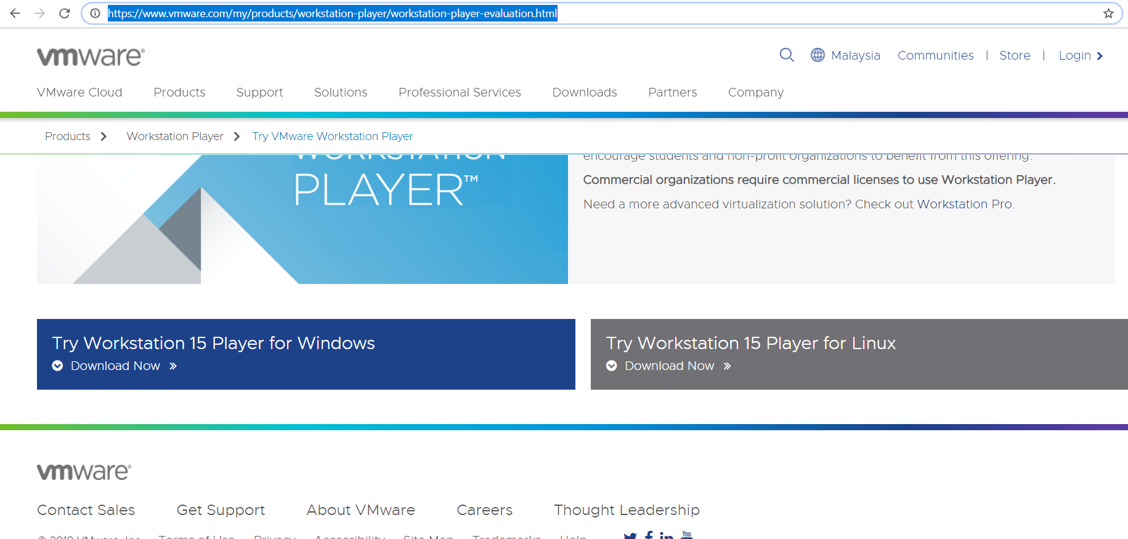

1. Run the Setup:

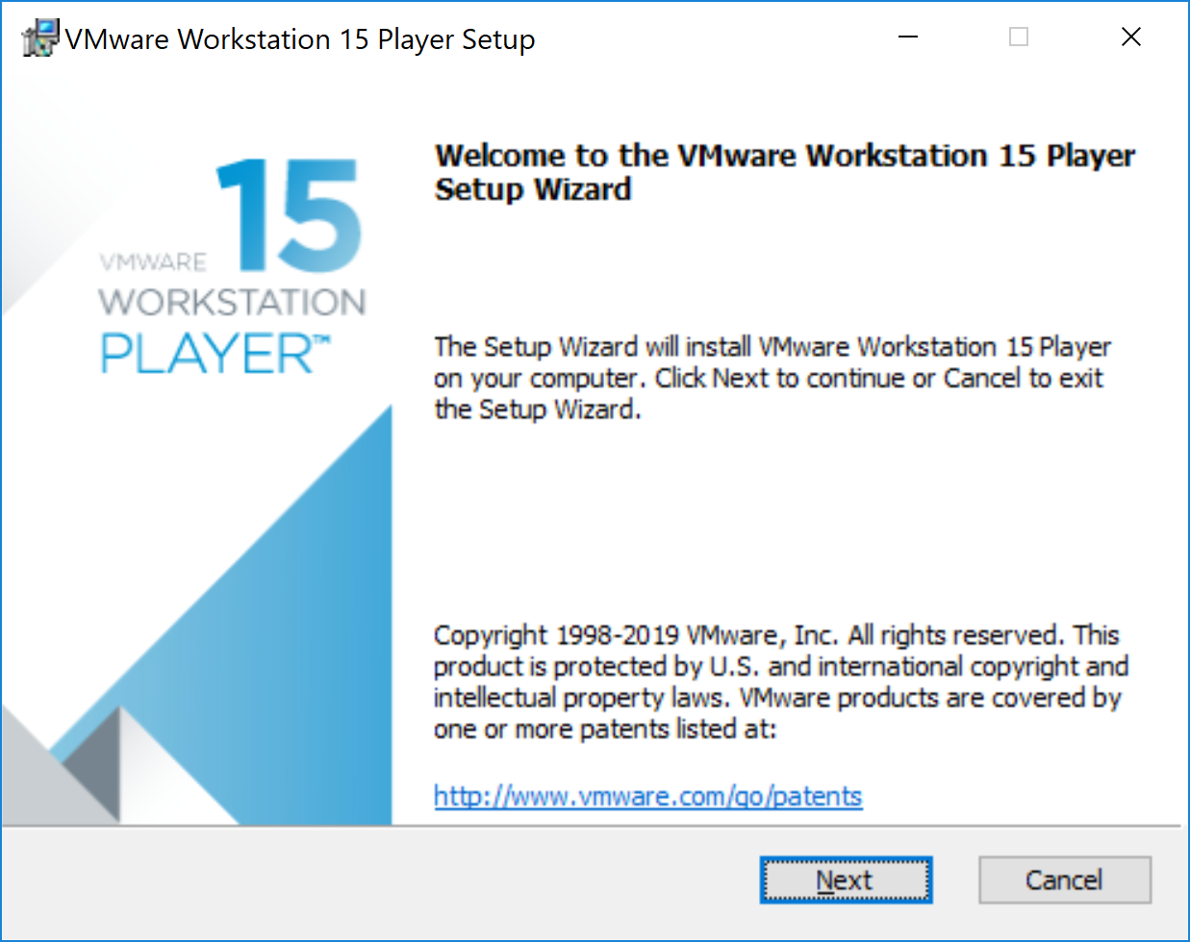

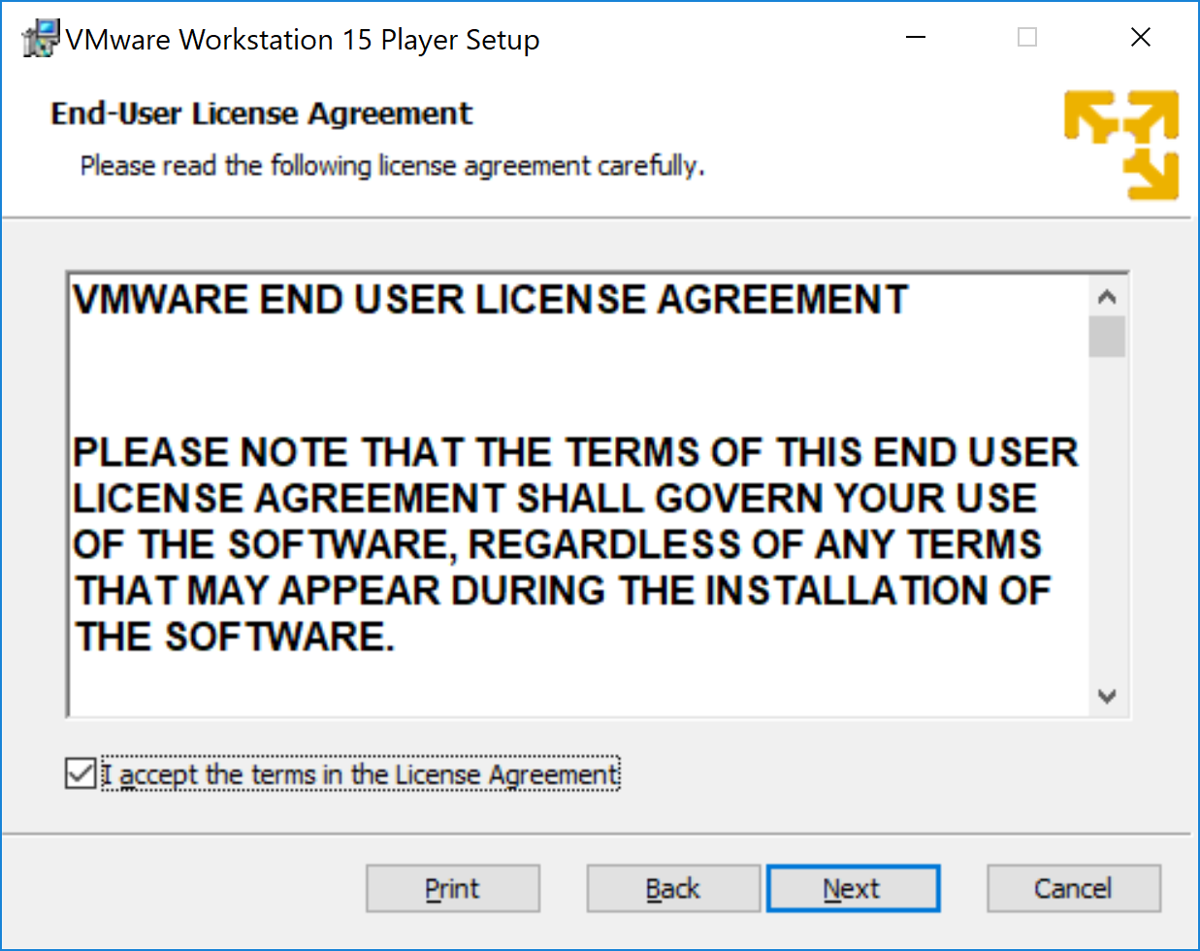

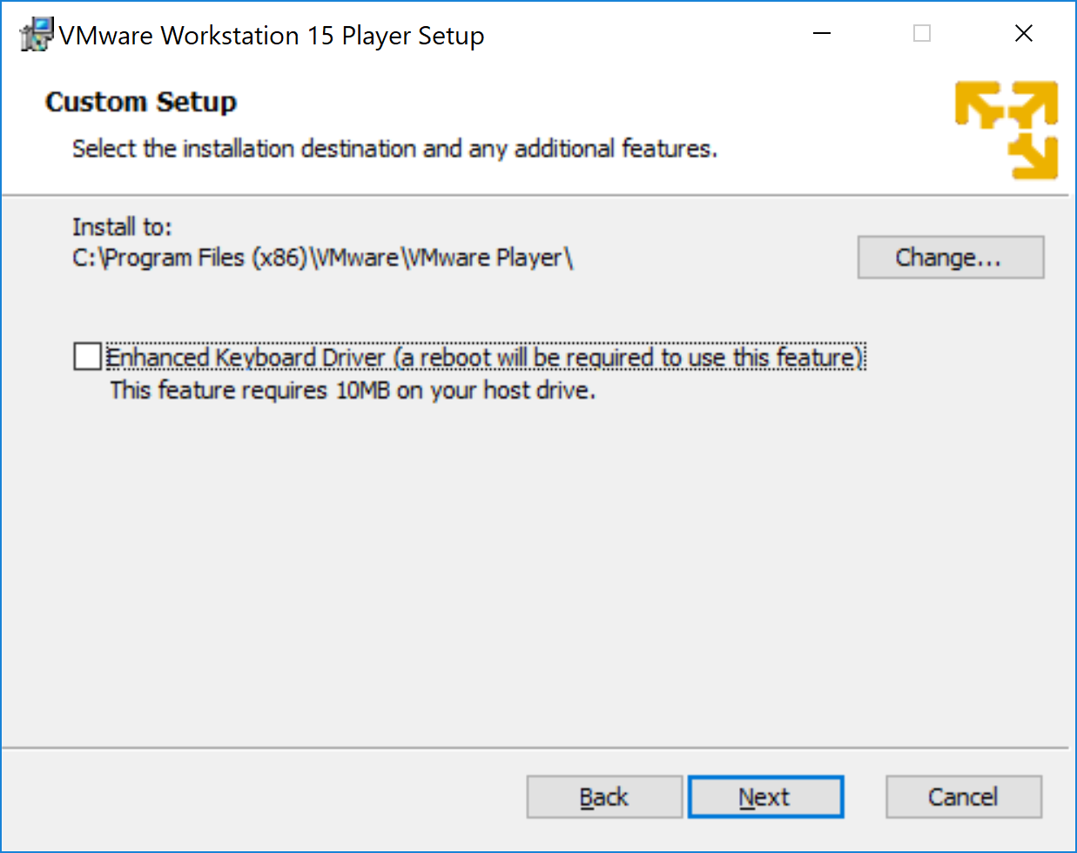

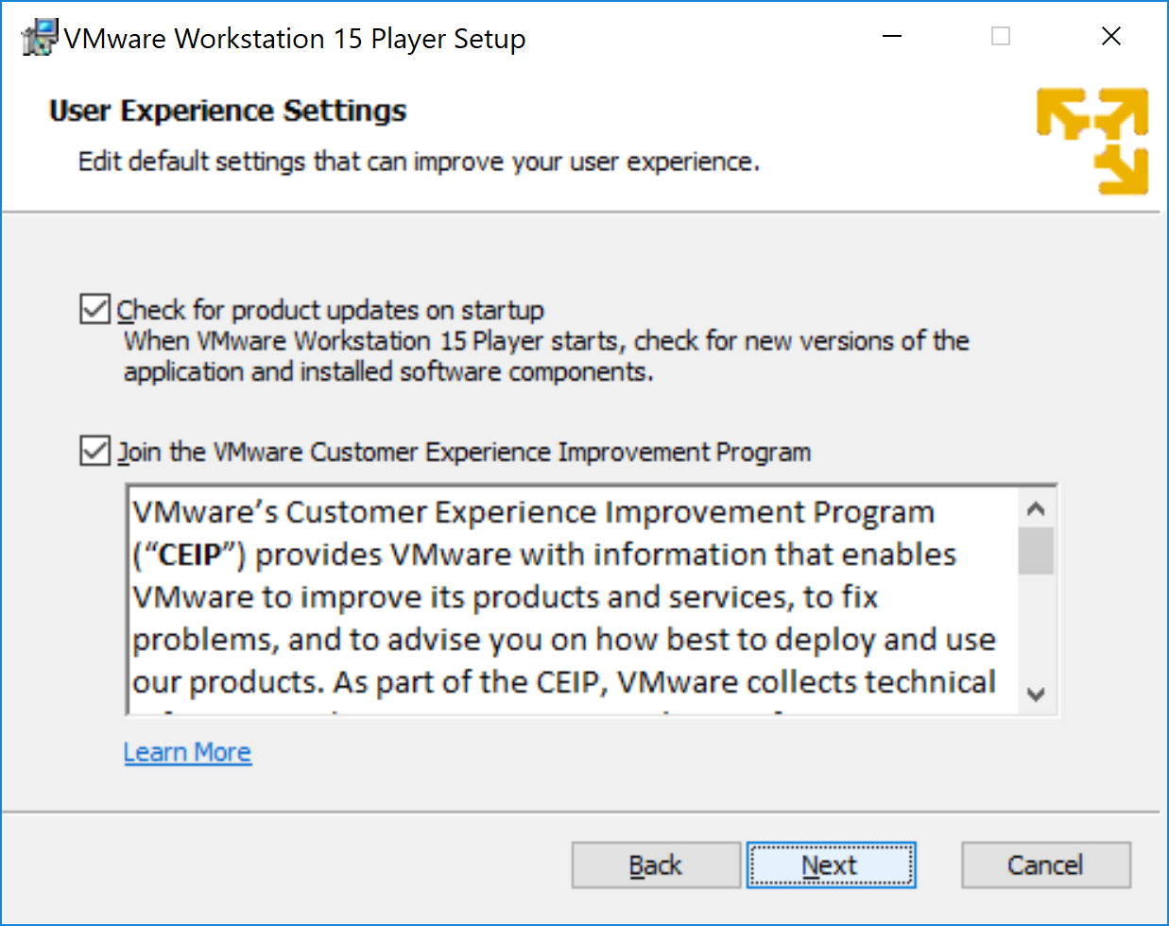

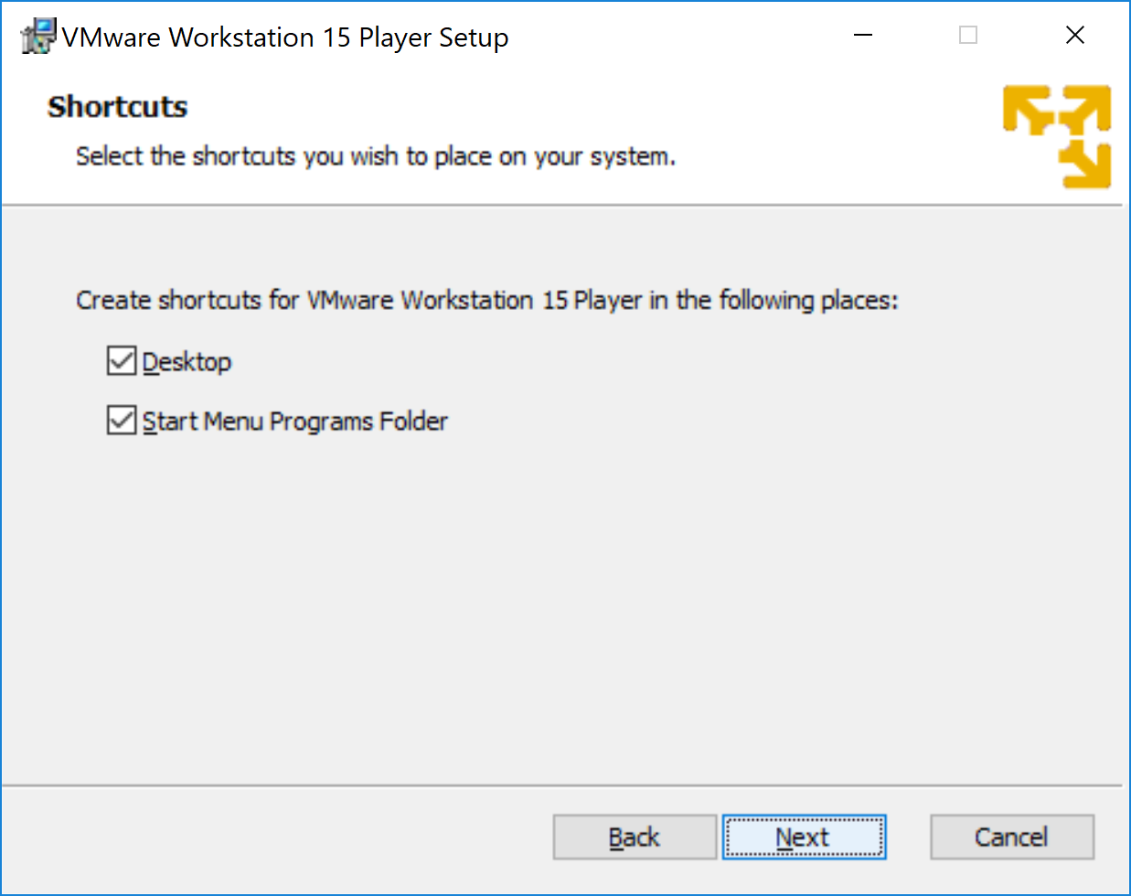

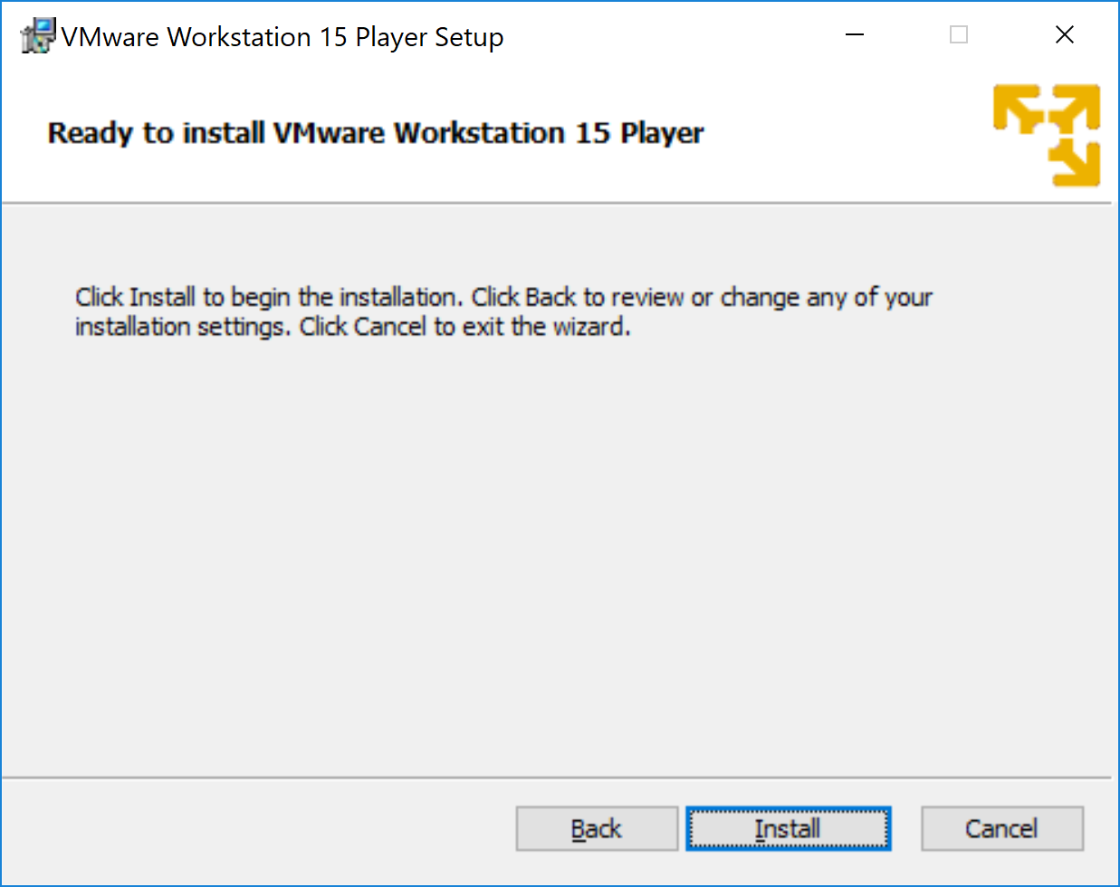

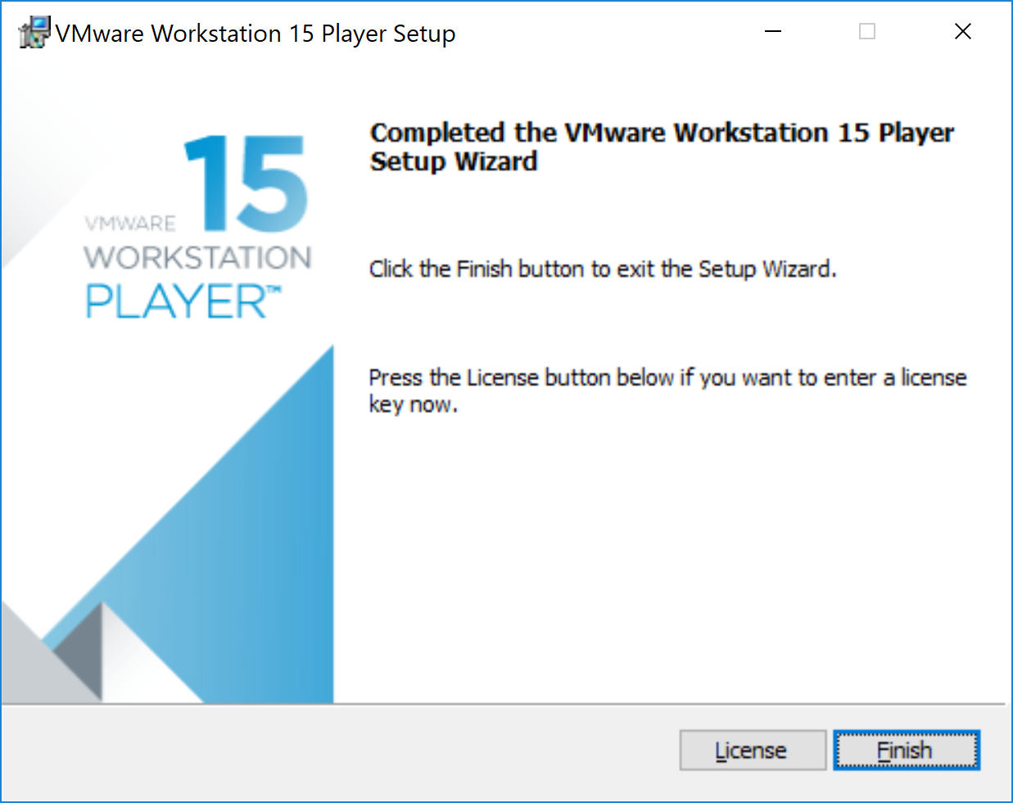

# Setup Hortonworks Sandbox in VM Player

1. Open VM Player.

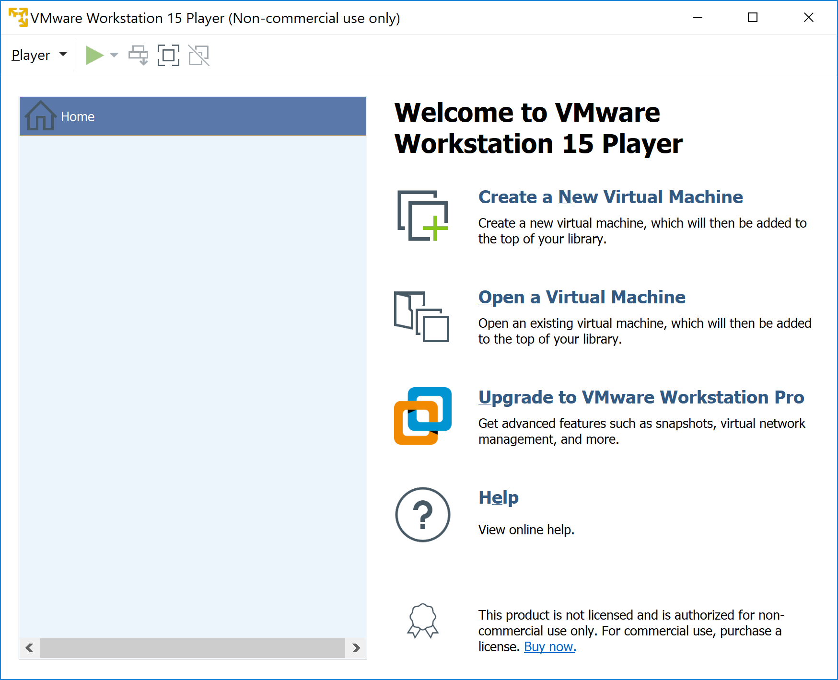

1. Click on “Open a Virtual machine” and browse for the Downloaded Hortonworks Sandbox.

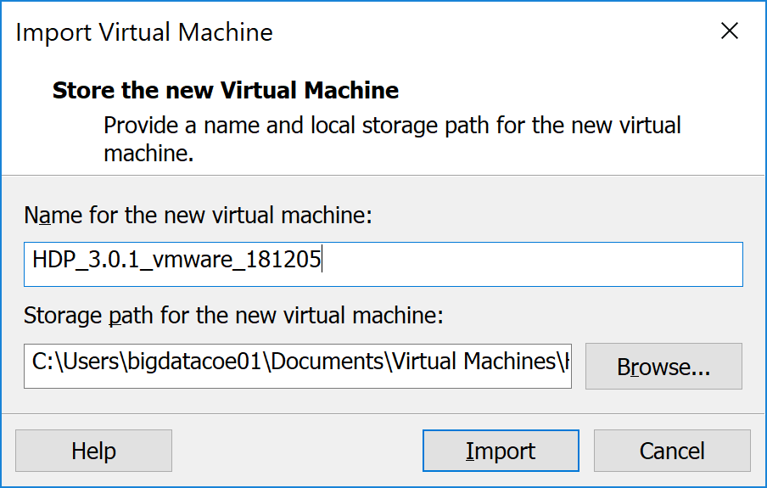

1. Click import to start the import of Sandbox.

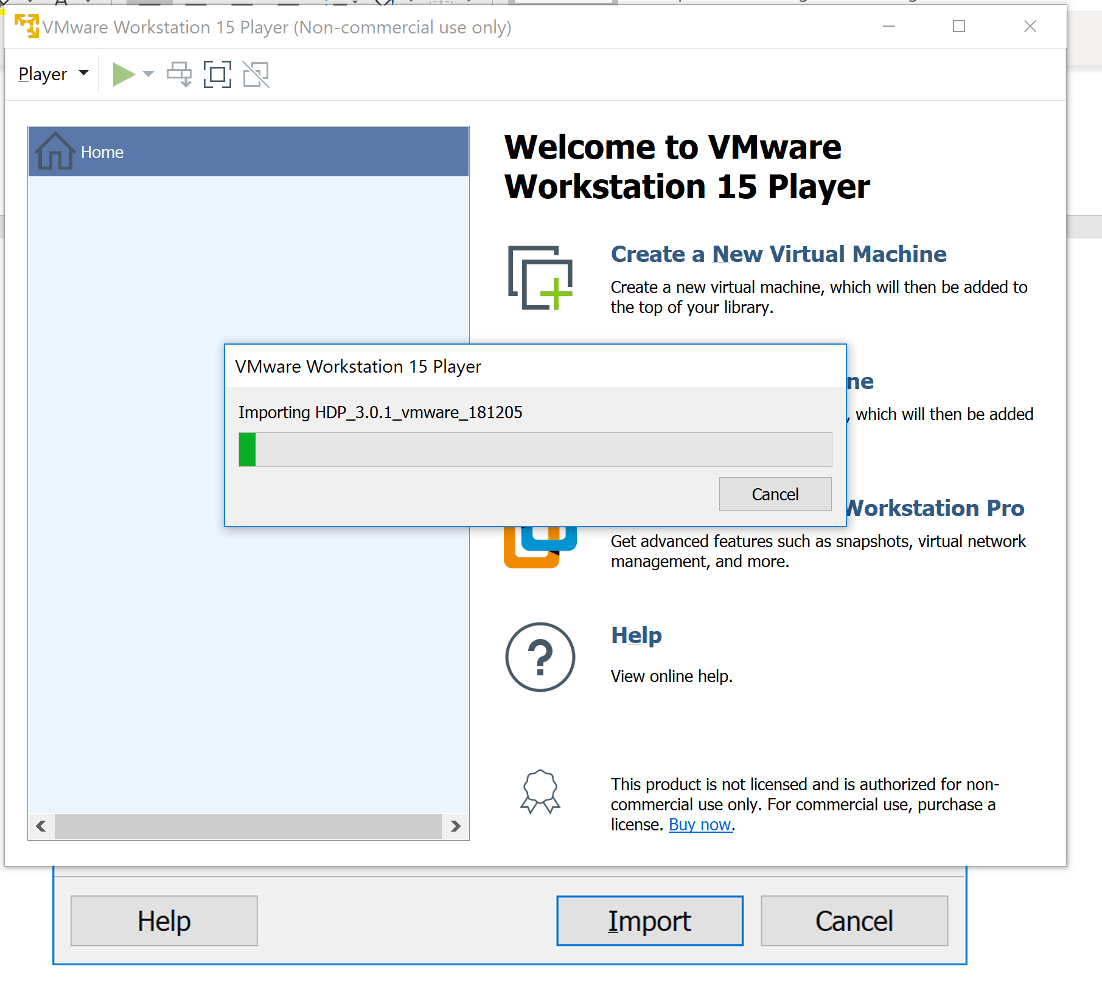

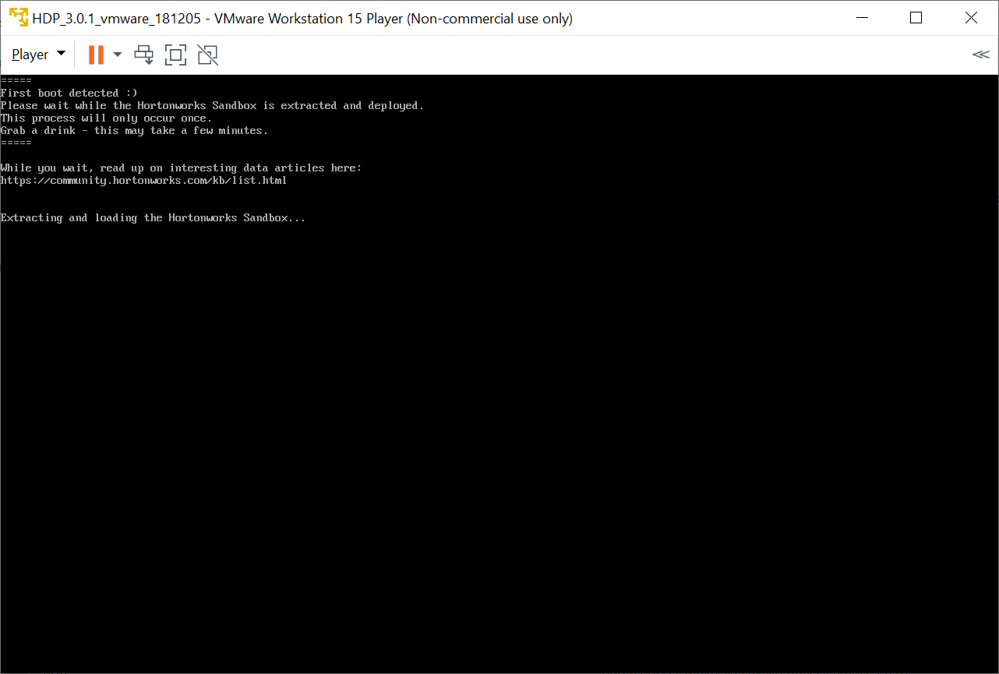

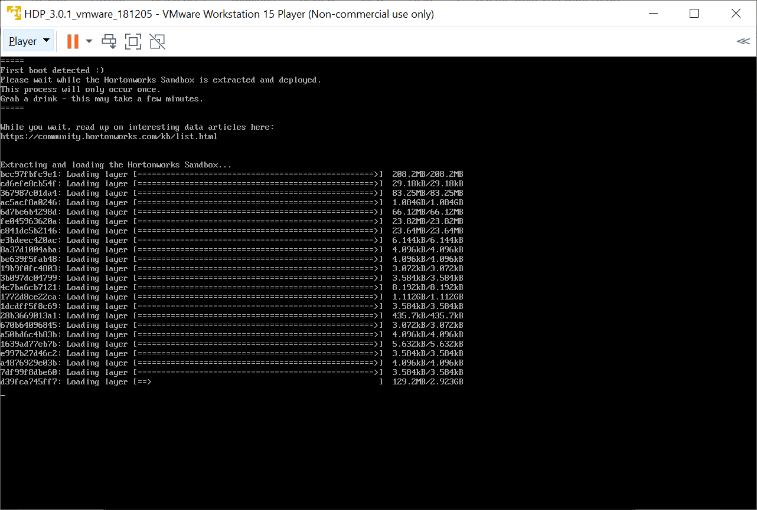

1. Once completed you will see the below screen with details for **welcome screen and SSH URL**.

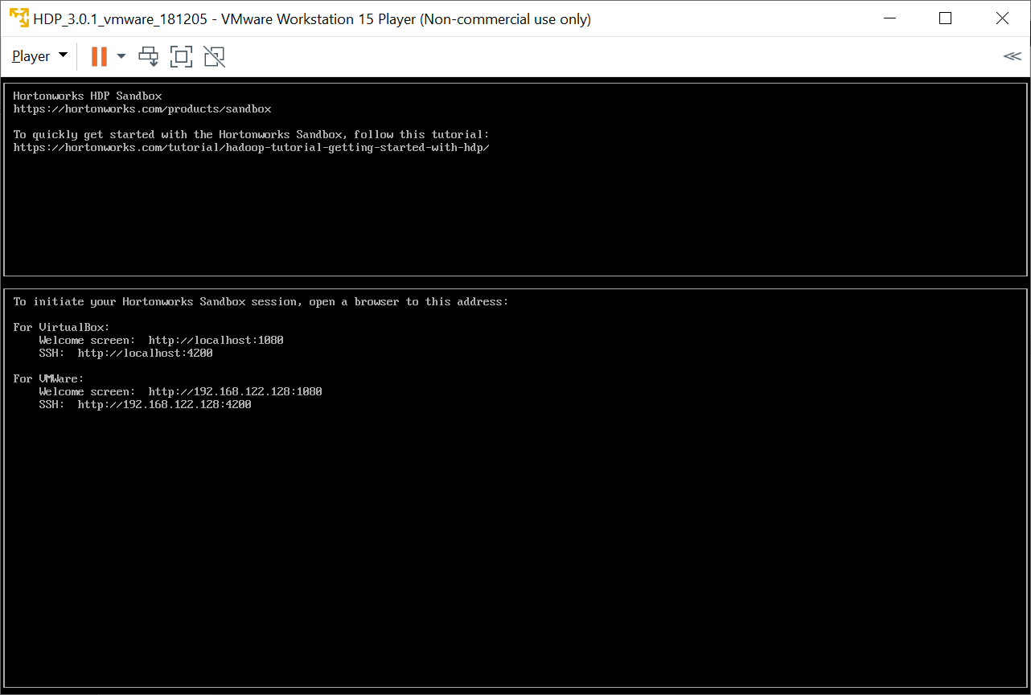

# Verify hadoop services using ambari.

1. Login SSH:

Go to the mentioned URL (i.e. 192.168.122.128:4200) to access SSH.

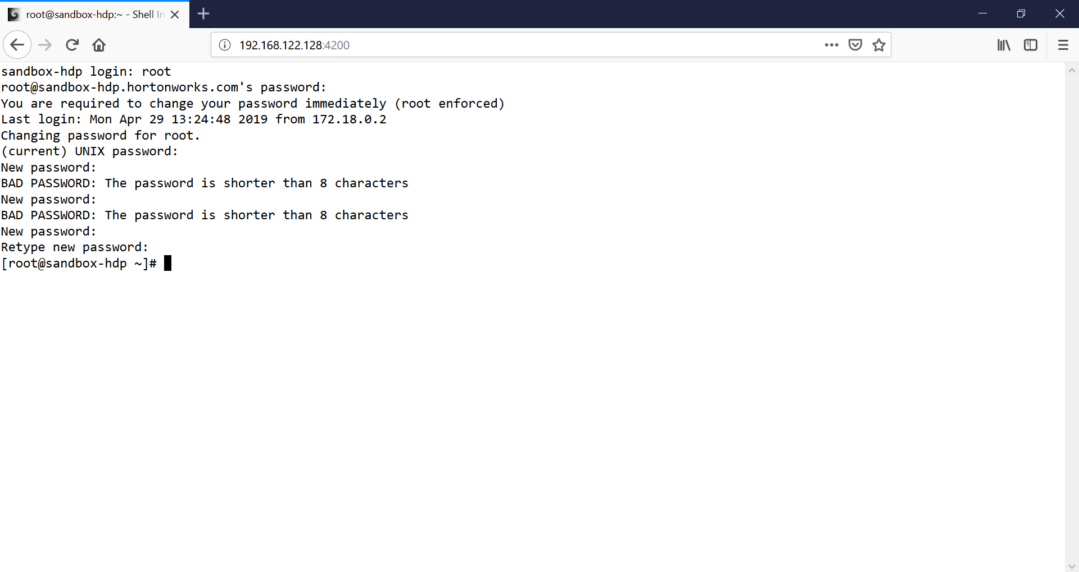

1. Change the admin password.

Type the command “ambari-admin-password-reset” and press enter.

Change the password.

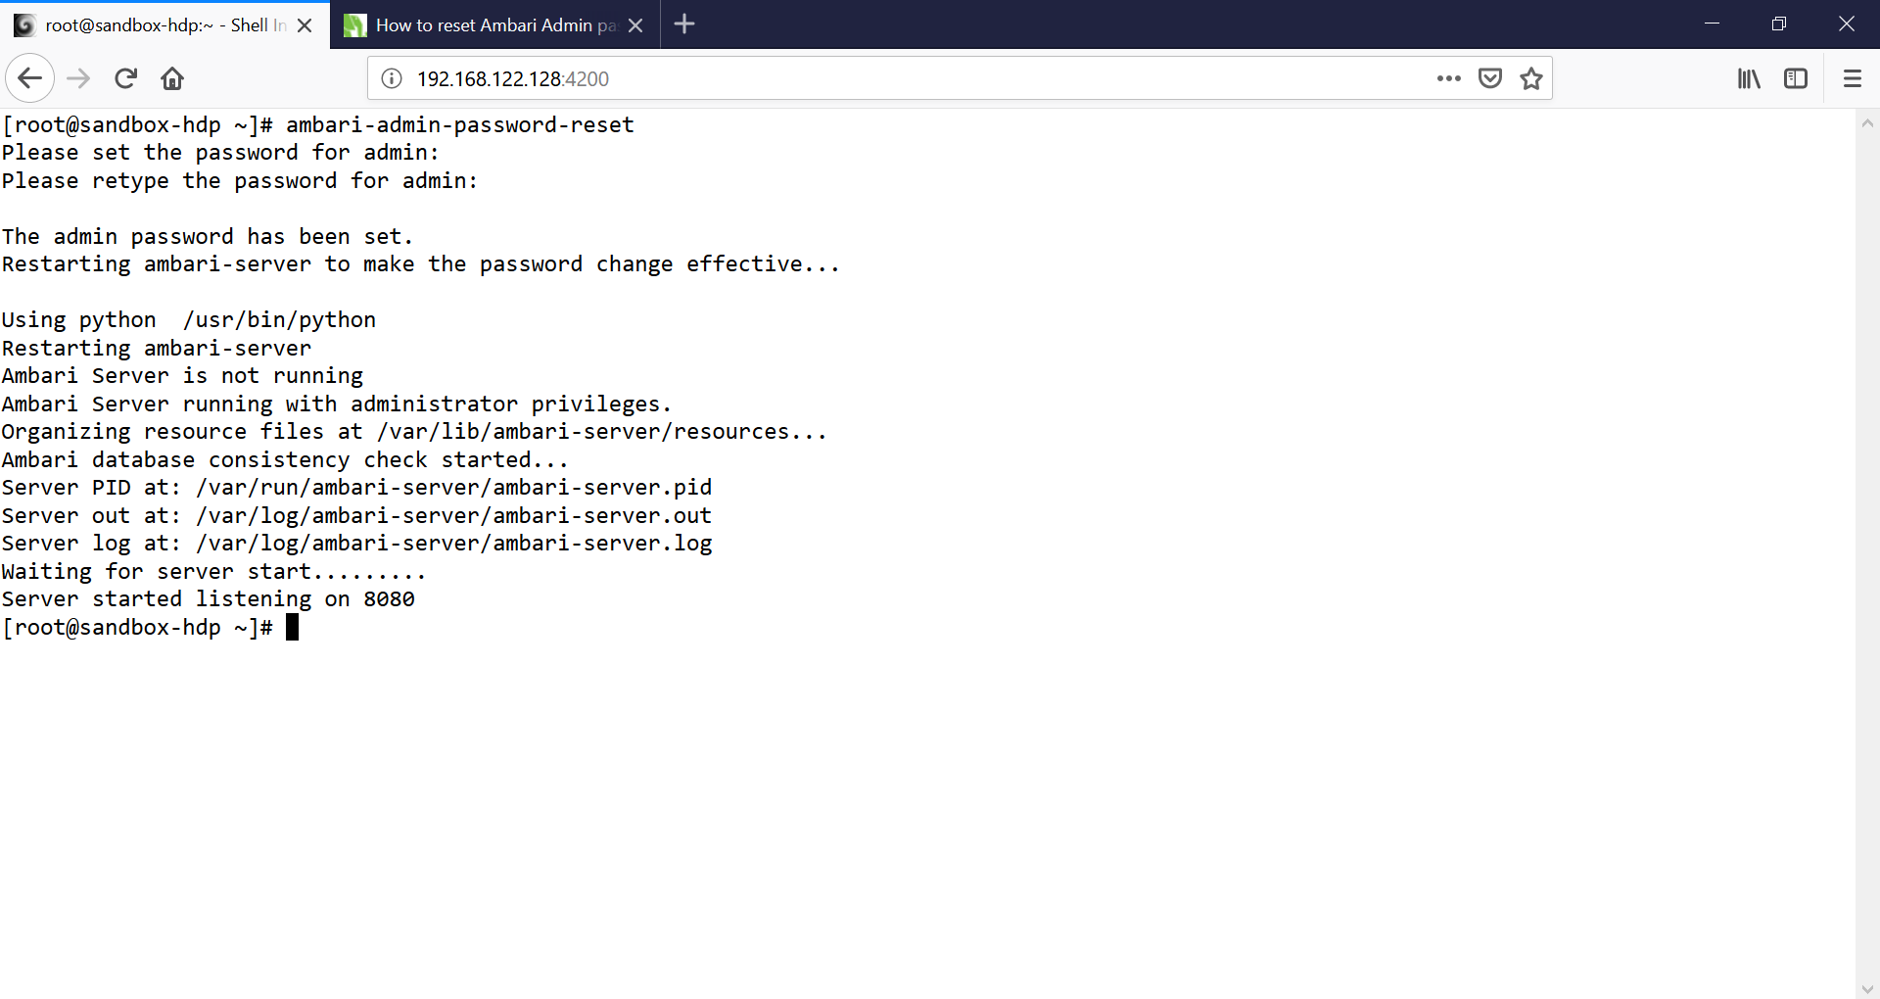

1. Login in ambari using admin.

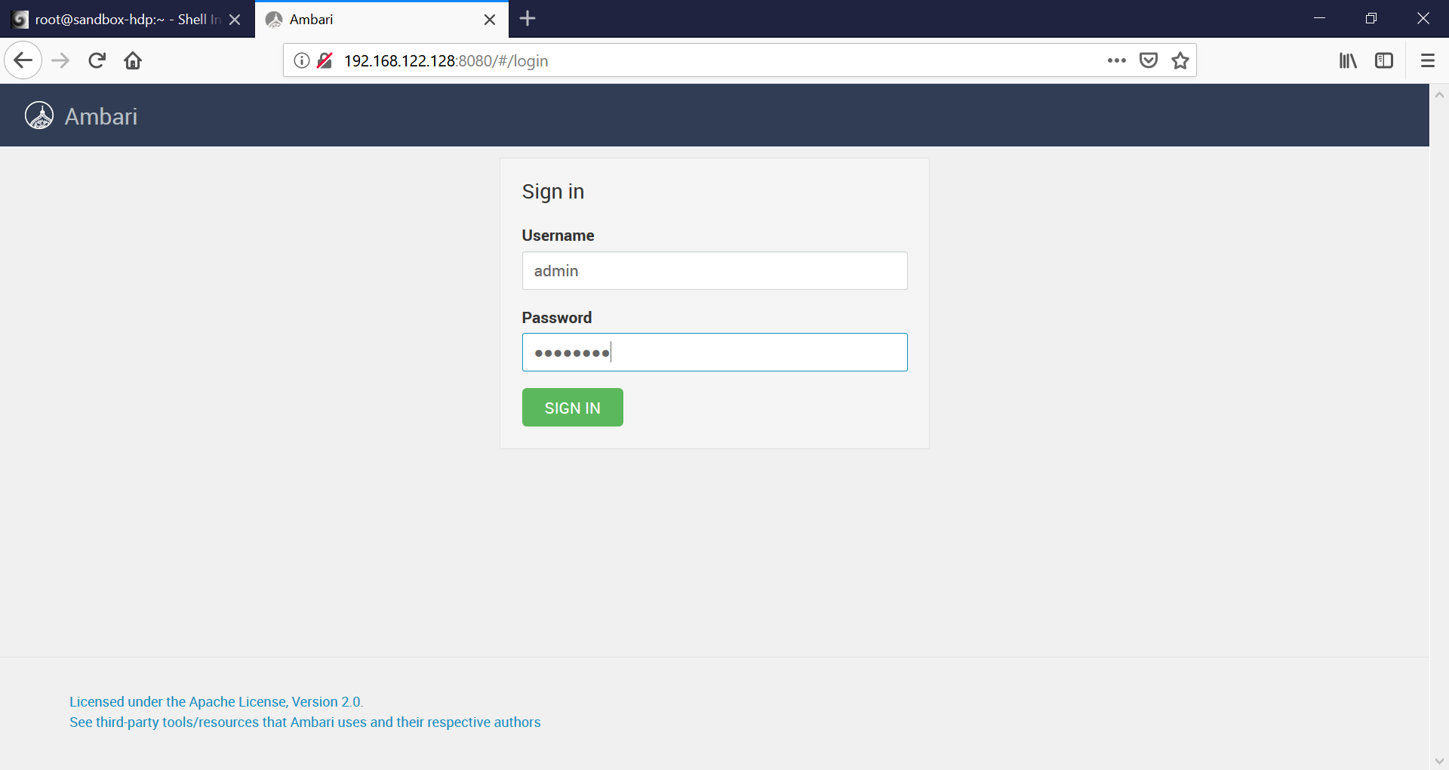

1. Check for the hadoop services. If not running restart all the services as shown in the picture below.

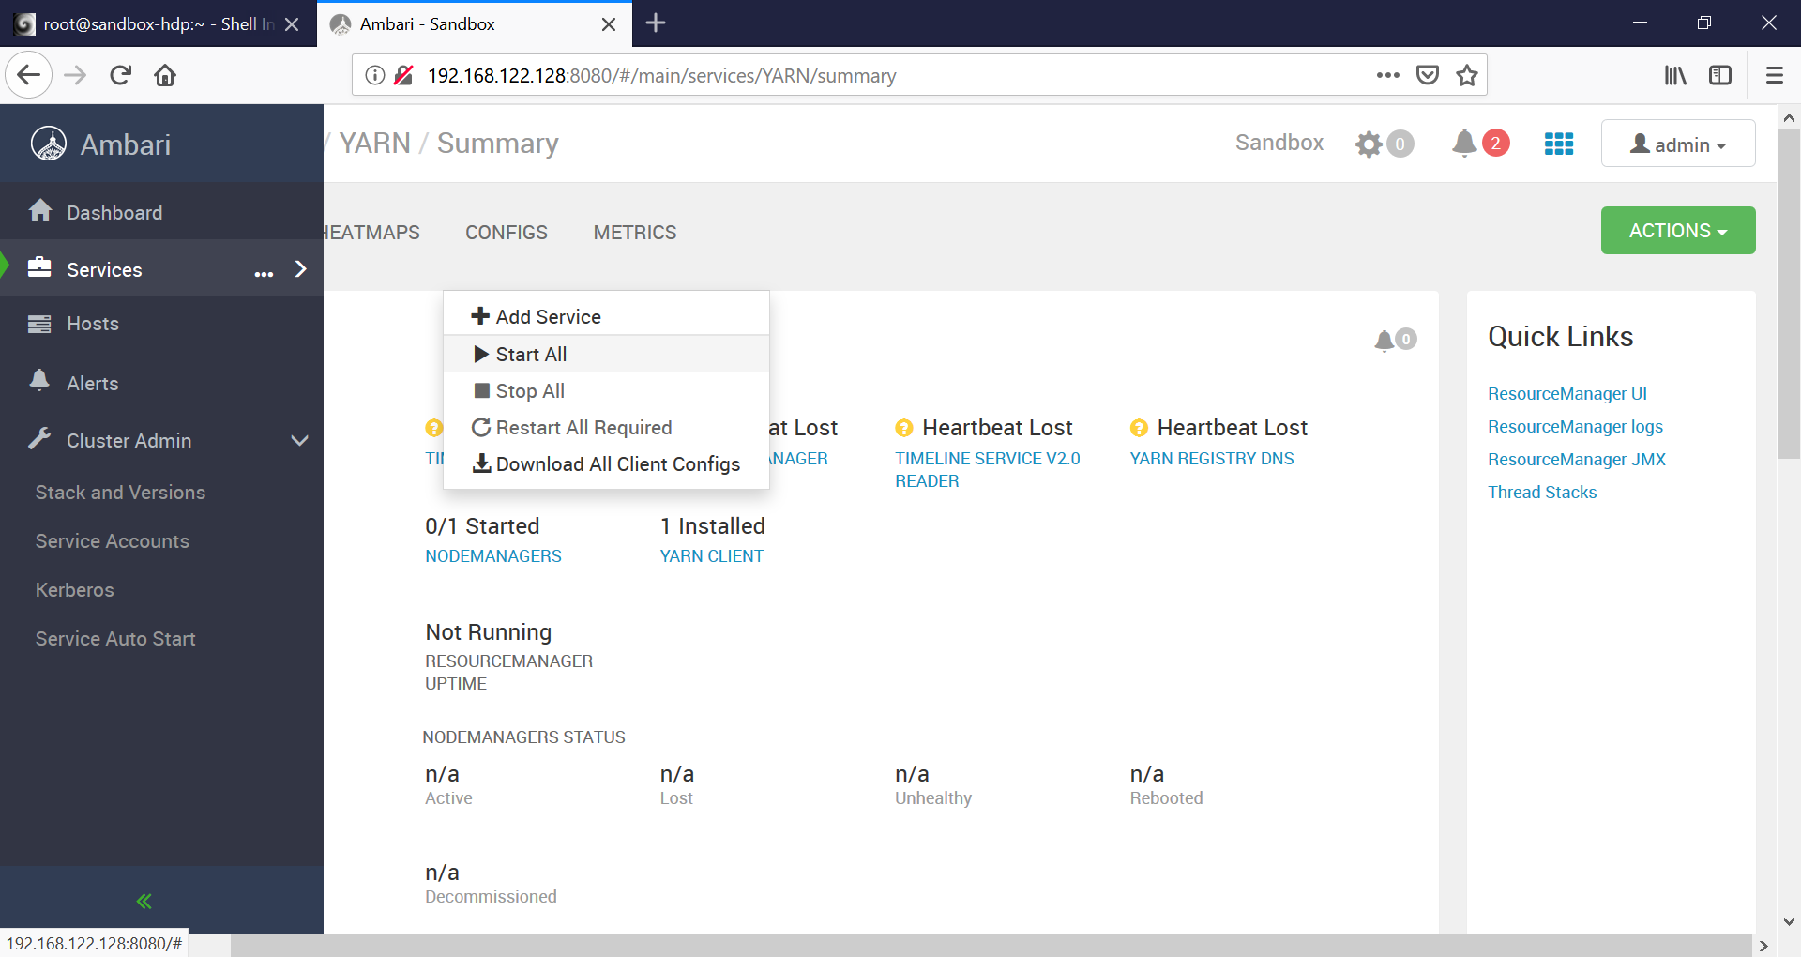

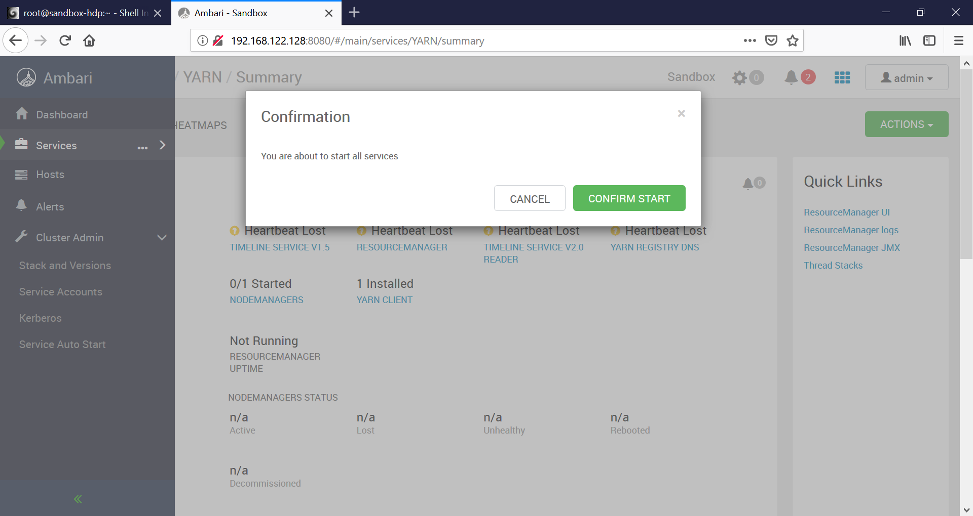

We will be using **maria_dev** user for the data engineer related work.